Sorry that all the screen shots are on a separate document, the photos would not load on my blog :)

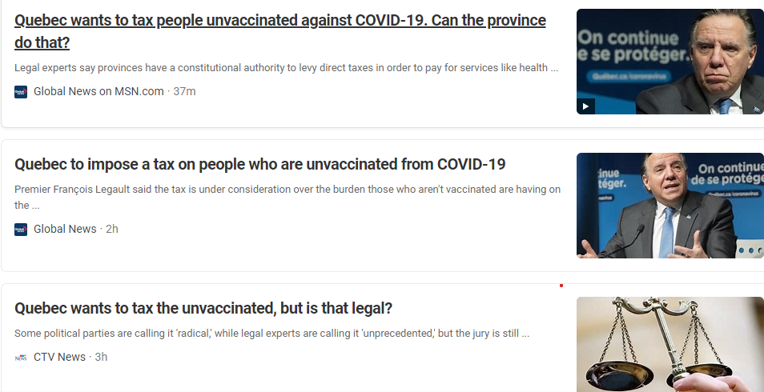Photos of the news articles I found

The video health briefing I found

