*unedited*

Please pick any song on the specific focus that we have discussed and choose a song in the same genre that you will analyze.

Example: I have shown you a specific song in ‘Jazz’ from my blog. Now you should look up a song based in the jazz genre and analyze the lyrics of the song after listening to it a few times.

Answer the following:

https://www.youtube.com/watch?v=3WdAaAhhb6M

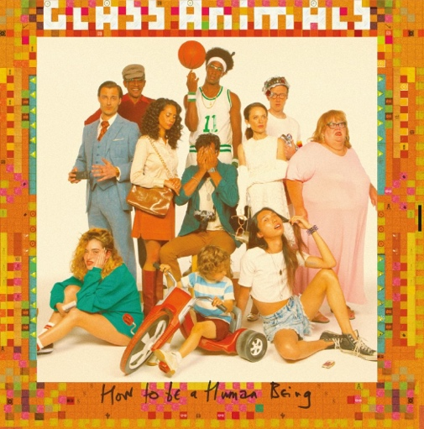
The Other Side of Paradise – Glass Animals
When I was young and stupid my love
Left to be a rock and roll star
He told me, "Please don't worry"
Wise little smile that spoke so safely
He booked a one way ticket
Out west, that's where they'd make it
Six kids stuck in a bedsit
To sunswept poolside riches
He met a girl who wore Versace
Pink feather coats and jumbo jewellery
Gonna be a hoop phenomenon
He's gonna be Hakeem Olajuwon
He's got a gold Camaro
He said over the payphone
I try to keep my cool but
My life turns in slow motion
Bye bye baby blue
I wish you could see the wicked truth
Caught up in a rush, it's killing you
Screaming at the sun, you blow into
Curled up in a grip when we were us
Fingers in a fist like you might run
I settle for a ghost I never knew
Superparadise I held on to
But I settle for a ghost
Where I was from in NOLA no one
Left to be a rock and roll star
He'd stay and treat his lady
Give everything to his new baby
I miss him, don't you blame me
That boy went stone cold crazy
Caught up in camera lust he's
Chasing that pappy pipe dream
I know you don't but I
I know you don't but I still try
My thunder shook him down
My thunder came and shook him down
That girl is gone but I
That girl is gone but I still try
I think it's over now
The bullet hit but maybe not
I feel so fucking numb
It hits my head and I feel numb
My body's looking wrong
My body's looking wrong
My body's looking wrong
Bye bye baby blue
I wish you could see the wicked truth
Caught up in a rush, it's killing you
Screaming at the sun you blow into
Curled up in a grip when we were us
Fingers in a fist like you might run
I settle for a ghost I never knew
Superparadise I held on to
But I settle for a ghost

- What is the story about? Give a summary of the story as you understand it.
The story is about naiveté and egoistic morals. About a man with big dreams, lost in wonder. He gets caught up in life and leaves his children and wife alone with nothing but a false sense of security. She grieves and regrets her decisions as the song captures her thoughts.
- What is the effect of this story as a song? How do the lyrics and sound combine to make a cohesive whole?
I absolutely love and adore this song. The lyrics are so exotic (like all their music) and well worth diving into. Glass Animals knows how to portray the essence of their music with both lyrics and sound. The initial part of the song is sung in a dream-like intonation, letting innocence take the wheel. Then Dave, the lead singer, slowly progresses into a mature voice, giving the emotion of anger and realization. The chorus is a grounded beat with a “who’s laughing now” vibe; it helps the listener distinguish the emotional collapses and mood swings. Especially the build-up to the final repetition of the chorus.
- Now that you know a little bit about stories in general, how is a short story different from a lyrical story? What are the pros and cons of both?
Short stories express more detail rather than lyrical stories. Because of this, lyrical stories use sound to capture their significance and tone. It’s important to note that short stories have more visible meaningfulness, as they have more stuff to read and observe. Music, however, is shorter and much more interpretation reliant.
- Put this idea into a lyrical narrative: (Poem story)
  - A talented young man’s deepest fear is holding his life back. Your character’s biggest fear is your story’s secret weapon. Don’t run from it, write about it.
Wind,
swept my heart away.
Yet there’s so much more to look for.
The meadow up at the top of the hill,
These glass panes see through me,
My Polaroid looking back at me,
The smile on her face.
The packet of cigarettes on the windowsill.
Freedom, freedom far and wide
Iron and wine the taste of candy.
Lately, I’ve felt nothing,
Yet I crave the taste of life.
The taste of flabbergasted smiles,
The dozen who hears my miracle trials,
From my very fearsome heart,
coated with envy.

*everything found below is no longer a part of the assignment*

The lyrics (Language)

- What did you like about the song's words? What were your favourite parts? Why? (Critical thinking)
One thing I love about Glass Animals, is the amount of fun they have producing their music.
“He met a girl who wore Versace. Pink feather coats and jumbo jewelry. Gonna be a hoop phenomenon, He's gonna be Hakeem Olajuwon,” is such an exotic lyric. There is another female involved, one with better looks and a bougee aesthetic. It’s wonderful to see the change in the wife’s demeanour once she expresses her annoyance, “I try to keep my cool but, my life turns in slow motion.”
Another lyric I enjoy is
“My thunder shook him down
My thunder came and shook him down
That girl is gone but I
That girl is gone but I still try
I think it's over now
The bullet hit but maybe not”
Once the wife realizes her worth, she tries her best to distance herself from this man. Nonetheless, she snaps as she’s trying to erase the memories of her ex-partner. She knows the Versace girl is gone, and in her mind, she still thinks of herself as a potential rebound. The wife, deep inside, is still willing to give him another chance. She understands that she must get away from his man’s grasp as soon as possible, but she continues to doubt herself, “The bullet hit but maybe not.”

- Are the song's words like the words to any other song that you know? How are they similar or different? (Connections)
“He told me, "Please don't worry"
Wise little smile that spoke so safely.”
The delicacy of the lyrics is unique and intricate. These unnecessary, yet soothing adjectives add so much flavour to the emotion. Her partner is smart. He knows what he must do to convince his wife to stay and take care of their children, whilst he goes out doing who knows what. The “wise little smile” of his, perked my red flag right off the bat.
- Is there anything in the song that reminds you of something in your own life? (Personalization)
Not personally, but I often see (in media) such representations. One partner is benefiting off the relationship, whilst the other is biting off more than they can chew. A relationship should be as equal as possible, both must work just as hard to keep one another healthy and HAPPY. Like all of their music, Glass Animals encompasses extremely complex and difficult problems in the world using their lyrics. Simply using your significant other for benefits, will never be healthy.
- Do you find any of the words or sentences interesting? Confusing? Unusual? (Style)
The whole lyrics are a big mess to unscramble.
“He booked a one way ticket
Out west, that's where they'd make it
Six kids stuck in a bedsit
To sunswept poolside riches”
It captures the contrast between the husband’s extravagant poolside richness versus his children’s boredom and uneasiness. I don’t see lyrics that can create such a beautiful contrast very often.
- Did the songwriter include images that you find funny? Scary? Old-fashioned? Embarrassing? (Evaluation)
The other girl’s style was very 60’s. With the jumbo jewelry and Versace feather coats, I picture an old-fashioned fashion nerd. It’s a representation of today’s society and what we look at in terms of personality building. One good trait takes over and neutralizes the negatives.

- What senses (imagery – words that describe feelings) does the songwriter use in this song? Sight? Smell? Hearing? Taste? Touch? (Style)
I wanted to save this lyric for this question.
“I wish you could see the wicked truth
Caught up in a rush, it's killing you
Screaming at the sun, you blow into
Curled up in a grip when we were us
Fingers in a fist like you might run
I settle for a ghost I never knew
Superparadise I held on to
But I settle for a ghost”
Dave perfectly captures the feeling of distraught and repeated losses of hope. The anger that’s flying twirling and mixing into a beautiful mess. You hold onto that “super paradise” of the past, that’s long gone. A ghost. Hoping and wishing for the other to see the truth, the pain you so deeply feel. I can smell, hear, and practically taste the air in which she bathes.
- Why do you think the songwriter wrote this song? (Inference)
Perhaps to relay an experience they’ve had or to bring awareness to the treatment people can receive. Whichever gender, it’s valid to have issues with your partner. It’s normal, we’re only human. It’s a difficult journey, and only time will tell.
- What is this song about? Give a sentence describing the song. (Theme)

Envy, jealousy, naiveté, adolescence, hope and surrender. It’s about the dream you grasp onto and never feel like letting go of.

