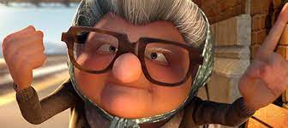
Snack Attack:
How are these characters familiar?

How are these characters overcoming stereotypes?
What kind of story is this?
https://www.youtube.com/watch?v=38y_1EWIE9I&ab_channel=EduardoVerastegui

Archetypes & Underdogs in Fiction
Carl Jung had a theory of connectedness – how we all fall into certain categories, and we all follow certain paths that are familiar to generations past and generations to come. How we are all really in a wheel. How the symbols we unconsciously use to represent aspects of our culture are somehow like other seemingly unrelated cultures. It’s in our human nature to categorize, package and contain while searching for answers through mysticism and imagination. Sometimes these lead to harmful outcomes, like unjustified stereotypes, yet some are warm and what one would call following tradition. In any case, the archetypical literary theory is close to us all.
This unit has to do with the archetypical literary theory. We will be discussing archetypes in popular fiction / short and long form film and non-fiction persuasive writing and how these archetypes can be translated into a bigger picture.
What you get out of the unit:
- Insight to Archetypical Lenses / Archetypical literary theory
- Connection to self, community, society through discussion, presentation, informal writing
- Watch Rocky I – one of the best journey movies ever - “The Underdog’s Journey”
- Formal annotated bibliography (Review)
- Read excerpts from David and Goliath by Malcom Gladwell
- How to write a 100-level literary analysis paper
My expectations are small at first as the unit will have heavy foundational scaffolding – to write about theory using the works provided as evidence, one must know all about the theory itself. By the end of the unit, you will be able to answer this essay question:
How are archetypes relevant in popular culture and how is the underdog’s journey a reflection of these relevant societal archetypes?
This unit will be broken down into four distinct parts. The first part is an introduction to archetypes. This will include a lecture and two short assignments that are completion marks.
We will then shift our attention to Malcom Gladwell’s David and Goliath and talk about the concept of the underdog – a popular archetype in fiction. You will read one chapter with two other people, complete an individual annotated bibliography, and present your findings to the class. Minor letter grade.
Then we will talk about Rocky – the ultimate underdog movie. First, I will teach you about a few film terms you need when analyzing film as literature. Then we will watch the movie, taking notes as we go. These notes will be your guide through the essay.
Finally, we will complete a literary analysis essay and answer the question How are archetypes relevant in popular culture and how is the underdog’s journey a reflection of these relevant societal archetypes? In order to complete this three-paragraph essay, I will give you a sentence-by-sentence structure so that you will not be lost. This type of essay will be new to you, and I realize that. We will take our time with this final section of the unit as it brings all of the elements learned into one three paragraph whole. Major letter grade.

PART 1:

Task 1: Characterization
You are to find a clip from a movie, TV show or animation and show me the different archetypes you find. Use the archetype PDF as an example and use the vocabulary that describes the archetype.

Task 2: Self Evaluation “My Archetype”
Take the Myer’s Briggs style test. Tell me what your archetype is – what this means to you and whether it is an accurate categorization of who you are as an individual. It is argued that all humans fall into 16 categories.
https://www.16personalities.com/free-personality-test

PART 2
Task 1:
Malcom Gladwell David and Goliath
After reading the Introduction as a class, you should be able to answer the following questions that we will discuss formally:
1. What does Gladwell mean by “giants”?
2. In what ways was David an underdog?
3. In the Bible, what happens between David and Goliath?
4. What is the common explanation of what happened between David and Goliath?
5. What is Gladwell’s original explanation of what happened between David and Goliath?

Task 2:
Each of the nine chapters in David and Goliath showcases Gladwell’s thesis through the prism of
different historical and academic arenas:
● Chapter One - Basketball
● Chapter Two - Class sizes
● Chapter Three - Selecting a university
● Chapter Four - Dyslexia
● Chapter Five - Childhood trauma
● Chapter Six - The Civil Rights Movement
● Chapter Seven - Authority figures
● Chapter Eight - Crime and punishment
● Chapter Nine - Nazis and the French resistance

Task 2 Continued:
Create an annotated bibliography on your chapter. Follow the structure for annotated bibliographies:
Part 1 (Summary)
1.The main idea of this article is…….

2.The topics covered in this article are…….

3.The author’s point of view in this article is……

Part 2 (Rhetoric) YOU KNOW THIS NOW!
1.The author of this piece is/is not credible because……

2.The author knows a lot about this topic because….

3.From this piece, the author wants you to………….

Part 3 (Reflection)
1.This article supports my ideas because…..

2.This article was helpful to me because….

3.This article added to my knowledge about this topic because….

Task 3:

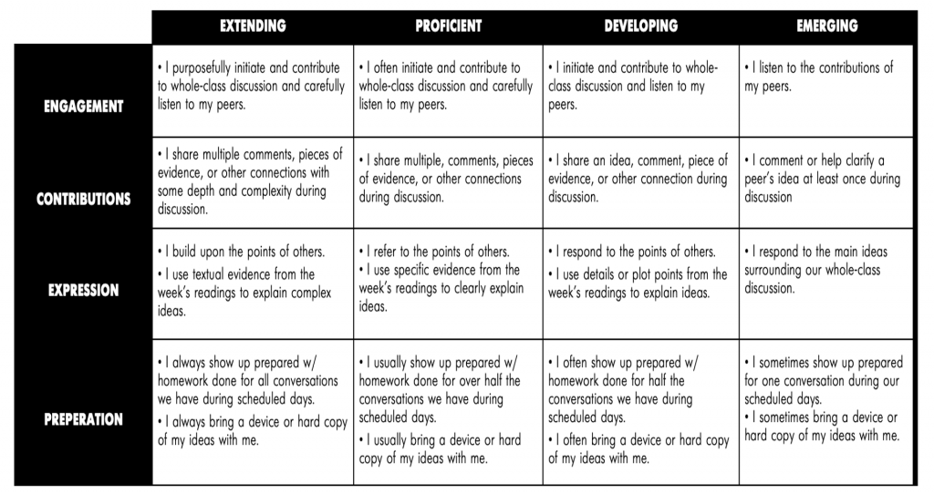
In each of those nine chapters, prepare a presentation with your two group members answering these questions:
1. Who and/or what are the Davids?
2. Why are those David more powerful than others presume?
3. Who are the Goliaths?
4. Why are those Goliath not as powerful as they seem?

PART 3 – ROCKY I (Secondary Source for Archetypical Literary Theory)
Task A: Film Terminology
Find your own clip!
Shots and Framing
Shot: a single piece of film uninterrupted by cuts.
Establishing Shot: often a long shot or a series of shots that sets the scene. It is used to establish setting and to show transitions between locations.
Long Shot (LS): a shot from some distance. If filming a person, the full body is shown. It may show the isolation or vulnerability of the character (also called a Full Shot).
Medium Shot (MS): the most common shot. The camera seems to be a medium distance from the object being filmed. A medium shot shows the person from the waist up. The effect is to ground the story.
Close Up (CU): the image being shot takes up at least 80 percent of the frame.
Extreme Close Up: the image being shot is a part of a whole, such as an eye or a hand.
Two Shot: a scene between two people shot exclusively from an angle that includes both characters more or less equally. It is used in love scenes where interaction between the two characters is important.
Camera Angles
Eye Level: a shot taken from a normal height; that is, the character’s eye level. Ninety to ninety-five percent of the shots seen are eye level, because it is the most natural angle.
High Angle: the camera is above the subject. This usually has the effect of making the subject look smaller than normal, giving him or her the appearance of being weak, powerless, and trapped.
Low Angle: the camera films subject from below. This usually has the effect of making the subject look larger than normal, and therefore strong, powerful, and threatening.
Camera Movements
Pan: a stationary camera moves from side to side on a horizontal axis.
Tilt: a stationary camera moves up or down along a vertical axis
Zoom: a stationary camera where the lens moves to make an object seem to move closer to or further away from the camera. With this technique, moving into a character is often a personal or revealing movement, while moving away distances or separates the audience from the character.
Dolly/Tracking: the camera is on a track that allows it to move with the action. The term also refers to any camera mounted on a car, truck, or helicopter.
Boom/Crane: the camera is on a crane over the action. This is used to create overhead shots.
Lighting
High Key: the scene is flooded with light, creating a bright and open-looking scene.
Low Key: the scene is flooded with shadows and darkness, creating suspense or suspicion.
Bottom or Side Lighting: direct lighting from below or the side, which often makes the subject appear dangerous or evil.
Front or Back Lighting: soft lighting on the actor’s face or from behind gives the appearance of innocence or goodness, or a halo effect.
Editing Techniques
Cut: most common editing technique. Two pieces of film are spliced together to “cut” to another image.
Fade: can be to or from black or white. A fade can begin in darkness and gradually assume full brightness (fade-in) or the image may gradually get darker (fade-out). A fade often implies that time has passed or may signify the end of a scene.
Dissolve: a kind of fade in which one image is slowly replaced by another. It can create a connection between images.
Wipe: a new image wipes off the previous image. A wipe is more fluid than a cut and quicker than a dissolve.
Flashback: cut or dissolve to action that happened in the past.
Shot-Reverse-Shot: a shot of one subject, then another, then back to the first. It is often used for conversation or reaction shots.
Cross Cutting: cut into action that is happening simultaneously. This technique is also called parallel editing. It can create tension or suspense and can form a connection between scenes.
Eye-Line Match: cut to an object, then to a person. This technique shows what a person seems to be looking at and can reveal a character’s thoughts.
Sound
Diegetic: sound that could logically be heard by the characters in the film.
Non-Diegetic: sound that cannot be heard by the characters but is designed for audience reaction only. An example might be ominous music for foreshadowing.

Task B: QUESTIONS
1. How does the non-diegetic/background score establish the mood of the film? Why is “ROCKY” so large as a title?
2. Where is the opening boxing event held? How is this setting ironic?
3. How is Rocky indirectly characterized by the first fight that we see? What does it mean to fight like a bum? Does Rocky fight like one?
4. Why do the filmmakers not open with the opening credits until after the fight? How is Rocky indirectly characterized by the setting of his apartment and how he behaves outside of the boxing ring?
5. What does Rocky likely think about when he looks at a picture of himself when he was younger? Why?
6. How is Adrian indirectly characterized by her costume and actions? How does Rocky behave around her? Why?
7. What does Rocky do to make money? Does it look like he enjoys his work?Why or why not? What is his relationship like with his boss?
8. Why is Rocky filmed via low angle? What has Mickey done with Rocky’s boxing gear? Why? How is Mickey indirectly characterized?
9. What is Paulie’s opinion of his sister, Adrian? How does he likely treat her? How does this treatment suggest why Adrian is who she is?
10. How is Apollo Creed indirectly characterized by his appearance and behavior in the TV interview that Rocky watches?
11. What advice does Rocky provide Marie, and how does she respond to it? How is this scene filmed and edited? Note the use of the Steadicam.
12. What is Apollo Creed’s conflict or problem? What’s his solution? Why does he want to fight the Italian Stallion? What’s a Southpaw?
13. What is Adrian’s internal conflict? Does she want to date Rocky? Why or why not? How does Rocky’s date with Adrian go? Why?
14. What is Mickey’s grievance with Rocky? Is he right? Why or why not? What is Rocky’s response?
15. What is Rocky’s initial reaction to Apollo’s request to fight him? Why does he ultimately agree to fight Apollo?
16. Why does Mickey want to manage Rocky for the fight? What is Rocky’s initial reaction? Why? Why does Rocky ultimately agree?
17. What does Rocky do to train? What is part of his routine? Why? How does the non-diegetic/background score change in this montage?
18. What is Paulie’s internal conflict? What does he say that is offensive, and what does Rocky say is Paulie’s problem?
19. What is Apollo more concerned with about the fight? How is this captured cinematically?
20. How does Adrian change in appearance and behavior? What diegetic song plays when Adrian confronts Paulie? How is this song ironic?
21. How does the non-diegetic/background score change as Rocky’s training continues? Also, what is shown in montage?
22. Why is Rocky filmed via low angle and slow motion in this training montage? How is he indirectly characterized by these choices?
23. How are the shots in the next scene juxtaposed? How is Rocky filmed in the arena before the fight? Why?
24. What does Rocky realize? What does he want to accomplish with this fight? Why?
25. What does Apollo Creed wear for his costume for the entrance to the fight? Why? How is he indirectly characterized by this choice?
26. What role do the announcers provide for the fight and the film? Why?
27. When, how, and why does Apollo Creed become a dynamic character? How does he begin to take the fight and Rocky seriously?
28. What is shown through the montage of the fight? How do people react to the fight (e.g. Adrian), and what happens throughout it? How does the nondiegetic/background score build and change?
29. What injuries do both Rocky and Apollo receive, and how are both indirectly characterized by their performances in the fight? What do they say to each other? Why?
30. How is the outcome of the fight a victory for Rocky?

Task B: Bringing it all together – Literary analysis essay:

- Answer this Question:
How are archetypes relevant in popular culture and how is the underdog’s journey a reflection of these relevant societal archetypes?
Keep in mind the frame: Archetypical Theory
Introduction:
1. Hook / literary theory used: Archetypes
2. Quote from outside source: Malcom Gladwell Chapter – See your annotated bibliography
3. Answer the elements of the question: Relevance of archetypes / Underdog focus
4. Introduce the Movie: Rocky
5. Make a Claim: Rocky – Underdog – Societal Norms
6. Explain the claim as it relates to your literary theory: Archetypes as a whole

Body Paragraph(s):
Framework:
Gladwell Quote #2
Connect to Rocky I
Evidence: Pivotal Scene in the Movie
Explain the two: Philosophy of Archetypes / Underdog / Journey of Rocky throughout the film
Repeat this again X2

Conclusion:
1. Idea Revisited:
2. Detail about the Idea:
3. Brief Quote from Journal:
4. Final Point Brought from Intro and explored further:

Rubric:
Essay Rubric

Exceeding | Clear and focused topic  Clear and complex thesis statement - specificity  Stylistically/syntactically sophisticated – demonstrating literary academic diction and tone  Complex structure (smoothly flowing transitions and argumentation)  Clear, focused paragraphs with convincing and elegant use of textual evidence.  Grammatically correct. Correct spelling.  Very insightful, critically/theoretically elevated analysis of the text/topic; goes beyond the literal
Meeting | Clear and focused topic  Clear thesis statement.  Structurally clear (clear topic sentences, paragraph coherence/focus, paragraphs have adequate connections to one another).  Solid use of textual evidence.  Grammatically correct. Correct spelling.  Provides solid insight into the topic’s meaning/significance.
Emerging | Lacks a clear argument.  Structurally unclear/compromised (a lack of clear topic sentences and/or unfocused paragraphs; paragraphs seem disconnected/scattered).  Grammatical/spelling issues  Inadequate use of textual evidence  Falls into plot summary; lacks adequate insight into the text
Incomplete / Rewrite | Not completed (amount written is inadequate).  Chronic grammatical/spelling issues that make the paper unreadable.  Substantial structural issues that make the paper unreadable.  Clear and pronounced misunderstanding of the requirements/genre of the assignment

