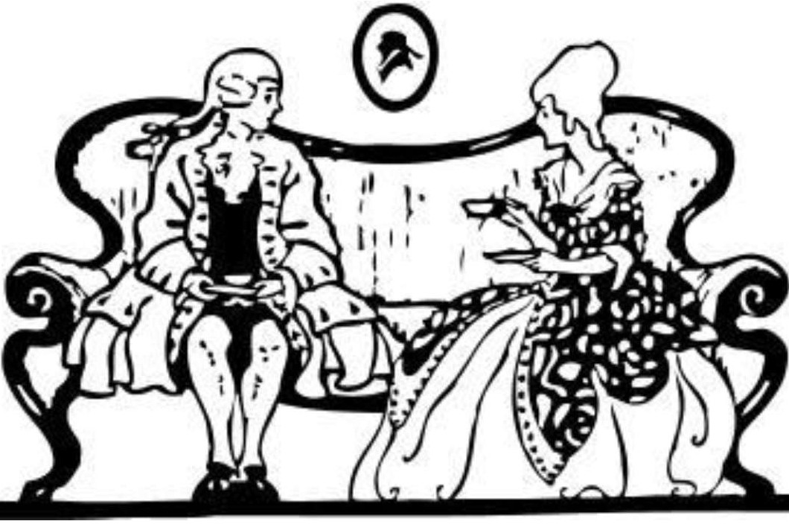

Importance of Being Earnest Discussion Questions

Act One

- Why does Jack Worthing call himself "Ernest" instead when he is in "town" (London)?

- Why has Algernon invented an invalid friend named "Bunbury"?

- Jack has an insurmountable impediment to marrying Gwendolen in his background: what, as Lady Bracknell sees it, is this problem? How does she propose that he resolve this problem? What is Wilde satirizing in this situation?

- How does Wilde use the subject of cucumber sandwiches to reveal the characters of Jack and Algy?

- How does Wilde satirize the vacuous mentalities and lifestyles of the British aristocracy in Lady Bracknell's interview with Jack?

- How does Wilde use the cigarette case to facilitate the exposition of the dramatic action?

- The character of Algernon Moncrieff reflects the public persona of the dramatist himself: in what ways in Algy like Wilde? Refer to background information.

- Why is the classical allusion in which Wilde compares Lady Bracknell to the Gorgon particularly apt? You may look this answer up BUT CITE YOUR SOURCE!

- The other classical allusion, to the Emperor Augustus, is more oblique: why did Wilde choose the name "Augusta" for Lady Bracknell? You may look this answer up BUT CITE YOUR SOURCE!

- What is the essence of such Wildean aphorisms as the following?" "[Women flirting with their own husbands] looks so bad. It is simply washing one's clean linen in public."

- What point is Wilde making about journalism in general and reviewers in particular when Algernon remarks, "You should leave that [literary criticism] to people who haven't been at University. They do it so well in the daily papers"?

- What tools of satire -irony, juxtaposition, understatement, paradox -are apparent in this opening act? CITE SPECIFIC LINES FROM THE PLAY.

Act Two

- "Gwendolen and Cecily are not so much opposites as complements." Explain this remark by reference to their speeches and actions.

- Early on in Act One Jack Worthing articulates the difference between city life and country life. Show three ways in which the life of the country (as exemplified by the Manor House, Woolton, Herfordshire) is very different from the bachelor life of The Albany, London.

- Like Jack, Algy leads a double life, utilizing an escape mechanism when necessary to free himself of a life of social obligation and lead a life of unrestrained pleasure. Explain their differing motivations, but how both are "confirmed Bunburyists," nevertheless.

- The comedy of mistaken identity is a very old dramatic form - as old, in fact, as comedy itself - which Wilde manages to revitalize in The Importance of Being Earnest. The key mistaken identity in this play, of course, is that of "Ernest" himself. What comic consequences result from Algernon's assuming the role of Ernest Worthing?

- In what ways would the terms "hedonist," "aesthete," and "gourmand" be suitable descriptors for Algernon? You may look this answer up BUT CITE YOUR SOURCE!

- How would you characterize Canon Chasuble and his relationship with Miss Prism? Why does Wilde include them at this point in the play?

- Give five examples of Wilde's wit, comedy and/ or satire in this act. How does this further his satirical purpose?

- A subtle sub-theme of the play is readers, publishers, fiction, and censorship. What points by implication is Wilde making about contemporary literature?

- What role does food have within the play? (Notice how Jack and Algy are eating muffins at key points - and then those pesky cucumber sandwiches in Act 1...)
- Based on the types of comedy discussed, how would you define The Importance of Being Earnest thus far? Defend your selections using textual references.

Act Three

- Lady Bracknell has been described as "the perfect embodiment of the attitudes and rules of conduct of the British aristocracy." How does Wilde unmask the mercenary motives of Lady Bracknell to reveal her essential snobbishness and hypocrisy in the final act?

- To a certain extent, Miss Prism and Dr. Chasuble are also satirical figures through whom Wilde attacks British institutions, namely education and the Church of England. Explain briefly what aspects of these institutions Wilde is satirizing.

- Define the term "bunburying," and explain its significance in the play. How does bunburying relate to Wilde's critique of Victorian earnestness? How are even Cecily and Dr. Chasuble "bunburyists"?

- The play has a number of objects that acquire additional meanings as the action develops. Explain how three of the following symbols in The Importance of Being Earnest relate to the plot and especially to the characters: cucumber sandwiches, bread-and-butter, the German language, French music and language, bottles of champagne, teacake, muffins, and the capacious handbag.

- "Although we see little of them, each of the butlers has a back story and serves as a vehicle for Wilde's satire of the aristocracy." Explain.

- If the principal characters will go to any lengths to avoid their responsibilities and place self- interest at the top of their own agendas, then a resolution of the conflicts in the play would be impossible: somebody has to make concessions. How does the resolution scene in the third act resolve the conflicts between Lady Bracknell and Jack? Jack and Algernon? Gwendolen and Cecily?

