English 12: Understanding Critical Theory
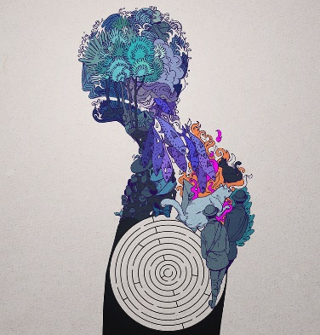
To really comprehend a text, we need to understand the levels of critical theory that comes from true analytical writing – context & subtext.
By the end of the semester, I hope that you will be ready to know how to form an argument, stand on the shoulders of published literary giants and see, through a theoretical lens, your own truth to why we study literature.

Texts we will Study:
The Importance of Being Earnest – Oscar Wilde
Pinball 1973– Haruki Murakami
Ru – Kim Thuy
Frankenstein – Mary Shelley
Various Short Stories – Wolff / Gaddis / Chiang / Compton
Rhetoric & Oratories – Lee Maracle / Martin Luther King Jr. / Walker Percy

Units We will Cover:
Literary Theories - Aestheticism, Queer Theory, Post Modernism, Psychoanalytical, Ethical,
Reader Response, Cultural, Existential
Narrative Non-Fiction
Creative Writing: Contemporary Literature / Post-modernism / Fragmentary
Final Symposium – Lenses Explored through debate (Independent Reading)
Annotated Bibliographies - 4
Literary Analysis papers - 3

Grading Overview

Long Game Assignments (MA) 60% | Short Game Assignments (TQ) 25% | Participation & Attendance  (HP) 15%
Murakami Analysis 1250  Thuy Analysis 1000  Synthesis Paper 1500  Symposium Final:  Choose Written Work | Rhetorical Essay  Earnest Analysis 750  College App Narrative  Short Story | Discussion  Attendance  Quizzes

Rules & Expectations
Be on time / do your work / don’t cheat / get used to being independent / don’t complain / communicate / be prepared / don’t be pretentious blowhards / take risks / keep negativity far from me / ask questions / keep an open mind / never give up / don’t hand in late work
IMPORTANT: All work should be handed in on Teams unless we come to another arrangement individually.
Most pieces will be on my blog: www.mycharlesbest.sd43.bc.ca/rpurdy I will update this blog daily / weekly. Please see it before class to be prepared. Rarely, I’ll have paper copies, mainly because of my schedule.
All in all, I thrive on positivity, originality, and exploratory discussion. Never feel as though you’ve taken on too much. My door is always open if you want to talk about an idea in detail.

Additional Work
- I expect you to keep a journal until February 28th (One Month – Tentative) – so you can reflect on what you’ve learned and apply these skills to a personal record. You’ll have time in class to complete it. Free writing is such an important part of the creative and analytical process. I will give daily quotes to inspire this writing. This will also be connected to annotated bibliographies

