Purdy
Wind / Pinball Introduction
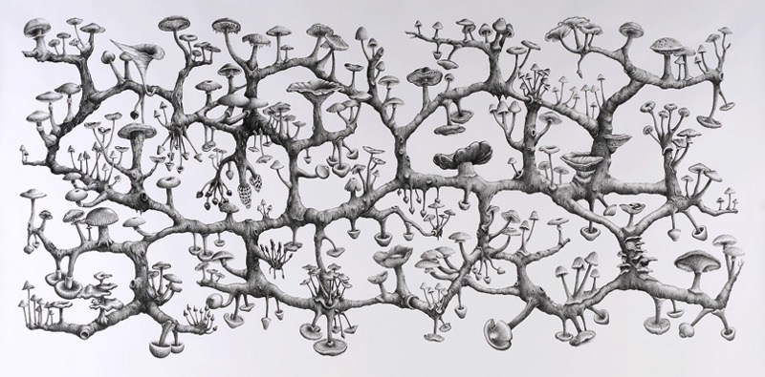

A Postmodern perspective is one where we all know that life is fragmented, and that we will never know about what it truly means to be a human being. We know parts of a whole, but like a Rhizome, we can only see a part of what it is we are capable of. The picture above is of each civilization – just one mushroom – and to traverse the branches of knowledge is to also assimilate to now two forms of being and the acceptance of such.
Postmodern literature is that of a ‘slice of life’ – meaning you take a part of a life, usually created from an idea. There is no structure, it’s only a snapshot into someone’s time on the planet, their ‘branch’ or ‘mushroom’ in the Rhizome. Why or what we grow on is a mystery and the acceptance of that is what makes Postmodern literature work. It’s a very selfish theoretical lens.
Look around you as you read this novel in class and at home. Pay attention to the nuances and everyday lies / drama you tell yourself and others. This is an exercise, if you will, in finding your own truth through the figurative picture of words. I will go in depth with you about this as the novel progresses.

Assignment
- Readings and discussions that are focused - student centered based on accessible questions that I will bring up as we progress.
- Small writing assignments (three) that will play with the idea of a ‘slice of life’ style writing that we will share every Monday. These assignments will lead up to the larger story – something you can be proud enough to put in a portfolio or even send out for publication.
- The major assignment: an (up to) 1500-word short story that is fully realized. This is your story. I would like you to use some concepts we’ve discovered throughout the course of the unit. You can start when you feel you’re ready.

Notes:
The rubric for the short story is very generalized. Your creativity and successful grade for this piece is the process in which you come to concrete ideas. Like all art, the experience is subjective.
That being said, here’s the rubric!

 | Got it | On Your Way | Needs Work
Quality Writing | All are met:  Dialogue, vivid word choice, stays on topic, good details, interesting/ creative, attention grabbing start, sentence variety | Some are met:  Dialogue, vivid word choice, stays on topic, good details, interesting/ creative, attention grabbing start, sentence variety  Setting is included and attempts to support the plot | Few are met:  Dialogue, vivid word choice, stays on topic, good details, interesting/ creative, attention grabbing start, sentence variety
Conflict | Main conflict is clear and adds to the story | Main conflict may be attempted but is not clear/partially developed | Main conflict is weak and not developed
Point of View | Clear and remains consistent (1st or 3rd) throughout the story Yes _____ No _____
Format and Conventions | Formatting of essay is perfect, and 0-3 spelling, punctuation, or grammar errors are present. Paragraphs and dialogue are used appropriately | Formatting of essay is perfect, and 4-6 spelling, punctuation, or grammar errors are present. Paragraphs and dialogue are used somewhat appropriately | 1 or more formatting errors exist, and/or 7+ spelling, punctuation, or grammar errors are present. Paragraphs and dialogue are not used appropriately

Major assignment: Grade is out of /25

