Poetry Portfolio
- HAIKU POEM
- CINQUAIN POEM
- ODE POEM
- FREE-VERSE (SLAM) POEM
- SONNET POEM

Drafting: Read the types of poems & examples. Pick your theme (Pg. 2). Write drafts of your poems. Add titles to your poems. Be sure to put the type of poem at the top of each poem.
Editing: Edit poems. Add poetry terms & check poetry resources (Pg. 3)
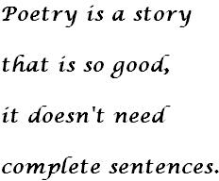
Poetry Portfolio Themes

Directions: Look over the list of poetry themes & brainstorm some of your own theme ideas in the box below. Then, narrow it down to your top choice. If you choose your own theme, make sure you get approval from The Fuscinator.
OWN THEME IDEAS:

TOP 2 THEME CHOICES:

TOP THEME CHOICE:
- A Dancer’s World
- A Fairy Tale Experience
- Who Am I?
- Choices and Consequences
- The Supernatural
- Technology versus Nature
- The Views of War
- The Deep Ocean
- The Canvas of an Artist
- Uncertainties in life
- A Life Lost too Soon
- Past, Present and Future Self
- Good Versus Evil
- Moments in Time
- The Spirit of an Athlete
- Fire and Ice
- Beneath the Mask
- Day and Night
- Behind the Stage
- A Passion for Music
- Through a Child’s Eye
- A Journey of…

Poetry Terms: Add some to each poem to enhance your poetry writing!

Alliteration: Common in poetry. This is the repetition of an initial sound (1st letter) in two or more words of a phrase, line, or sentence. Example: Fusco’s Focused Friday

Hyperbole: A figure of speech - an exaggeration or overstatement.

Imagery: This is used to describe the words or phrases which bring forth a certain picture or image in the mind of the reader. Imagery appeals to the senses - what can be seen, heard, felt, etc.

Metaphor: A comparison between two seemingly unrelated subjects without using “like or “as.” (Love is a walk in the rain at night, Stars were diamonds in the sky)

Mood: The feeling or atmosphere the writer creates for the reader.

Onomatopoeia: Words that sound like what they mean. For example, buzz, snap and boom.

Oxymoron: A combination of contradictory terms (cruel kindness, love hate)

Personification: A figure of speech in which human qualities are assigned to non- human things, or life is given to inanimate objects.

Repetition: The repeating of a word or phrase to create a rhythm or make a point.

Simile: A comparison between two seemingly unrelated objects using the words “like” or “as”. (Life is like a box of chocolates, you never know what you’re going to get)

Symbol: Something concrete, like an object, person, place or action that stands for something more abstract, like an idea, a feeling, or emotion.
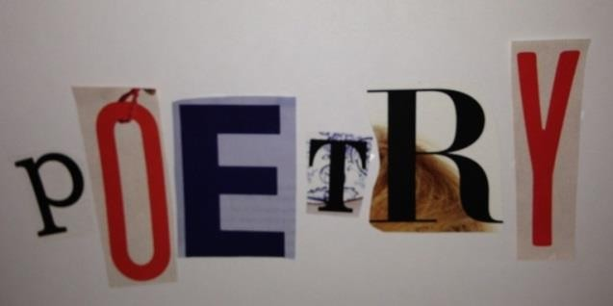
Poetry Resources: www.shadowpoetry.com & www.rhymezone.com

Embodied Poetic Narrative (or fractured Narrative) for spoken word ideas

- Find an ‘artifact’ in your bag.
- Put it in the center of your table.
- We’ll do a quick Kinesthetic warm up so you can get rid of your egos
- Focus on an object.
- Quietly go back to your desks, don’t talk to anyone else about anything
- Write for five minutes about the artifact
- One word that comes to mind from your story ‘word ball’
- Go back to your story and circle key words
- Export these chosen words to another piece of paper and reorder them as a poem
- Make a physical emblem from these poems (Through visual means aka. Draw a picture)
- Interpretive dance?

#1: Haiku
Haiku is an unrhymed Japanese verse consisting of three unrhymed lines of five, seven, and five syllables (5, 7, 5). Haiku is usually written in the present tense and often focuses on nature (seasons), feelings and/or experiences.

Student Example:

Crowded but lonely Master of horrible death Blindly takes your life

#2: Cinquain Poem
This poem is a 5 line poem, usually unrhymed, with 2 syllables in the first line, 4 in the second, 6 in the third, 8 in the fourth line, and 2 in the last line.

Student Example:

Alone
Quiet, Blissful
Focus, Practice, Relax
Mortal constrictions are unbound Peaceful

#3: Ode Poem
This poem should be at least 10 lines in length. An Ode is a poem praising and glorifying a person, place or thing.

Student Example:

Oh the sea!
Whose wave’s crash hard But yet so gently
Whose colors are different Just as peoples are
The sea is a home A getaway, a view,
A memory, a dream,
A movie, an experience In which we all should Treasure like a jewel
Until the next time we see the Beautiful waves crashing once More

#4: Free Verse Poem
This poem should be at least 10 lines in length (My rule). This is the most “free” of all poetry in terms of rules. Free Verse is an irregular form of poetry in which it is free of traditional rules such as rhyme. In moving from line to line, the poet's main consideration is where to insert line breaks. Some ways of doing this include breaking the line where there is a natural pause or at a point of suspense for the reader.

Student Example:

The light
At first sitting
So silently in the background, Makes its way out.

Night is in the open, Ready to pounce And attack.
The two contrast.
After circling each other like Worthy opponents,
The fight begins.

#5: Sonnet

A Sonnet is a poem consisting of 14 lines, each containing 10 syllables. See the organizer on the next page to assist you! Follow it carefully. One of the most famous of all Sonnets is Shakespeare’s Sonnet 18:

Shall I compare thee to a summer's day? Thou art more lovely and more temperate:
Rough winds do shake the darling buds of May, And summer's lease hath all too short a date: Sometime too hot the eye of heaven shines, And often is his gold complexion dimm'd;
And every fair from fair sometime declines,
By chance or nature's changing course untrimm'd; But thy eternal summer shall not fade
Nor lose possession of that fair thou owest;
Nor shall Death brag thou wander'st in his shade, When in eternal lines to time thou growest:
So long as men can breathe or eyes can see, So long lives this and this gives life to thee.

10  syllables each  line | My Line | Rhyme Scheme
 |  | A
 |  | B
 |  | A
 |  | B

10  syllables  each line | My Line | Rhyme Scheme
 |  | C
 |  | D
 |  | C
 |  | D

10  syllables each line | My Line | Rhyme Scheme
 |  | E
 |  | F
 |  | E
 |  | F

10  syllables each line | My Line | Rhyme Scheme
 |  | G
 |  | G

