ENGLISH 11: Theoretical Perspectives

Course Outline (2019/20)

Mr. Purdy – rpurdy@sd43.bc.ca
http://myriverside.sd43.bc.ca/rpurdy/

EVALUATION / WEIGHT:
- Major Assignments MA: 60% (various in-class essays, unit projects, oral presentations, final examination)
- Tests and Quizzes TQ: 15% (pop quizzes, quizzes to check reading, formative quizzes)
- Homework and Prep HP: 25% (Small assignments, outlines, rough copies, submission on due dates,
class discussions, signed interims, attendance, participation, etc.)

TEXT / FILM LIST FOR THE SEMESTER:
Dystopian Lit Kit
Tempest – Shakespeare (& MOVIE)
Lenses Writing) Film(s): Before Sunrise / Before Sunset
‘Modernism’ Various Short Stories & Novella: (Mansfield / Fitzgerald / Pushkin / Hemingway)
OTHER UNITS
Musical Mondays
College Narrative Unit
Critical Theory (Lenses)
5 Vocab Tests
Rhetorical Essays
PARTICIPATION / ASSIGNMENTS
A due date will be attached to ALL assignments or projects in the course. It is your responsibility to complete the work by the assigned date. The determination of your participation mark is based partially on your ability to stay with the pace of the course, submitting projects on the due date. Late assignments will only be accepted with a valid excused absence. 1 Point deducted each day late.

CLASSROOM EXPECTATIONS
Respect each other and the teacher / Be on time / don’t plagiarize / hand in paper copies of assignments / Be aware that this is a classroom. Be formal in your speech.

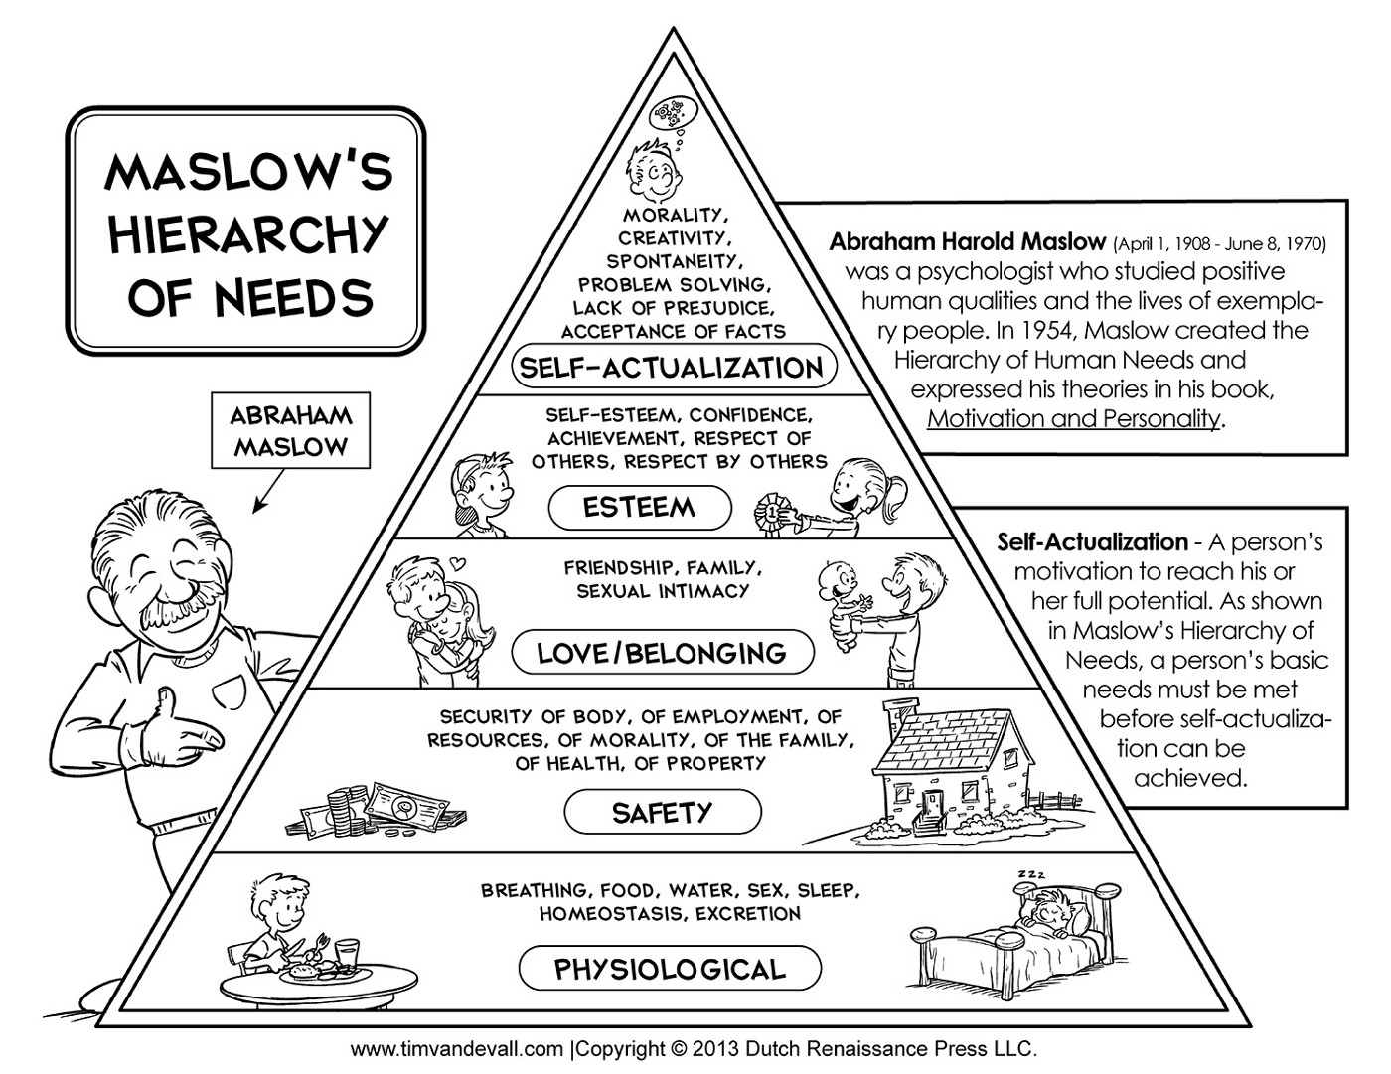

In a first world contemporary society, most of us have all of our basic needs met. According to Maslow, when contentment is found with general necessity, we all seem to be looking for a sense of purpose and control over our lives, thus being attracted to self- actualization and true meaning. Through this Semester, we will be looking at how different pieces of work will determine the essence of what it means to have control, what it means to question authority and what it means to be in a position of power. This will be through the applpication of different lenses.

Rough Calendar (Changes will Occur)

◄ August | ~ September 2019 ~ |  |  |  |  | October ►
Sun | Mon | Tue | Wed | Thu | Fri | Sat
1 | 2 | 3 | 4  1st Day of Class  Introductions  Syllabus | 5  Lenses Overview | 6  Lenses  Sitcom  Analysis  BYO Poem | 7
8 | 9  Lenses  Your own Poem  Vocab 1 | 10  Lenses  Your own Poem | 11  Lenses  Your Own Poem  500 Word Due | 12  Lenses  Before Sunset | 13  Lenses  Before Sunset  Vocab 1 | 14
15 | 16  Music  Mondays  PP1 | 17  In Class Writing  Lenses / Before Sunset | 18  Modernism  Lens –  Introduction | 19  Modernism  Story 1  Analysis Together | 20  PRO-D | 21
22 | 23  Music  Mondays  PP2  Vocab 2 | 24  Modernism  Story 2 | 25  Modernism  Story 2  Formative writing | 26  Modernism  Story 3 | 27  Modernism  Story 3  Formative Writing  Vocab 2 | 28
29 | 30  Music  Mondays  PP3 | Notes:

◄ September | ~ October 2019 ~ |  |  |  |  | November ►
Sun | Mon | Tue | Wed | Thu | Fri | Sat
 |  | 1  Modernism  Novella | 2  Modernism  Novella | 3  Modernism  Novella | 4  Modernism  Novella  Formative Writing | 5
6 | 7  Music  Mondays  PP4  Vocab 3 | 8  Final Essay Test  Modernism | 9  Dystopian Lit Kit | 10  Dystopian Lit Kit | 11  Dystopian Lit Kit  Vocab 3 | 12
13 | 14  Thanksgiving | 15  Dystopian Lit Kit | 16  Dystopian Lit Kit | 17  Dystopian Lit Kit | 18  Dystopian Lit Kit | 19
20 | 21  Music  Mondays  PP5 | 22  Dystopian Lit Kit | 23  Dystopian Lit Kit | 24  Dystopian Lit Kit | 25  PRO-D | 26
27 | 28  Music  Mondays  Final Paper  Vocab 4 | 29  Dystopian Lit Kit | 30  Dystopian Lit Kit | 31  Dystopian Lit Kit | Notes:

◄ October | ~ November 2019 ~ |  |  |  |  | December ►
Sun | Mon | Tue | Wed | Thu | Fri | Sat
 |  |  |  |  | 1  Dystopian Lit Kit Final Projects  Due  Vocab 4 | 2
3 | 4  Music Mondays  Presentations  -  - | 5  Poetry | 6  Poetry | 7  Poetry | 8  Poetry | 9
10 | 11  Remembrance Day | 12  Poetry  Vocab 5 | 13  Poetry | 14  Poetry  Final Presentation | 15  Poetry  Final Presentation  Vocab 5 | 16
17 | 18  Music Mondays  Presentations  -  - | 19  I Statement  Non- Fiction Narratives & College Apps | 20  I Statement  Non- Fiction Narratives & College Apps | 21  I Statement  Non- Fiction Narratives & College Apps | 22  I Statement  Non- Fiction Narratives & College Apps | 23
24 | 25  Music Mondays  Presentations  -  - | 26  I Statement  Non- Fiction Narratives & College Apps | 27  I Statement  Non- Fiction Narratives & College Apps | 28  I Statement  Non- Fiction Narratives & College Apps | 29  I Statement  Non- Fiction Narratives & College Apps  Due Today  Vocab Final | 30

◄ November | ~ December 2019 ~ |  |  |  |  | January ►
Sun | Mon | Tue | Wed | Thu | Fri | Sat
1 | 2  Music Mondays  Presentations  -  - | 3  The Tempest  Introduction  Lenses | 4  The Tempest  Act 1  Questions | 5  The Tempest  Act 2  Questions | 6  The Tempest  Act 3  Questions | 7
8 | 9  Music Mondays  Presentations  -  - | 10  The Tempest  Act 4  Questions | 11  The Tempest  Act 5  Questions Due | 12  The Tempest  Lenses Paper | 13  The Tempest  Lenses Paper | 14
15 | 16  Music Mondays  Presentations  -  - | 17  Tempest Final Lenses Paper | 18  Tempest Final Paper  DUE TODAY | 19  Tempest Film | 20  Tempest Film | 21  Winter Vacation
22  Winter Vacation | 23  Winter Vacation | 24  Winter Vacation | 25  Winter Vacation | 26  Winter Vacation | 27  Winter Vacation | 28  Winter Vacation
29  Winter Vacation | 30  Winter Vacation | 31  Winter Vacation | Notes:

◄ December | ~ January 2020 ~ |  |  |  |  | February ►
Sun | Mon | Tue | Wed | Thu | Fri | Sat
 |  |  | 1  Winter Vacation | 2  Winter Vacation | 3  Winter Vacation | 4  Winter Vacation
5 | 6  Music Mondays  Presentations  -  - | 7  Rhetorical Analysis Overview | 8  Rhetorical Analysis | 9  Rhetorical Analysis  Documentary  TBD | 10  Rhetorical Analysis  Documentary  TBD | 11
12 | 13  Music Mondays  Presentations  -  - | 14  Rhetorical Analysis  Paper | 15  Rhetorical Analysis  Paper | 16  Rhetorical Analysis  Paper  Early Submission | 17  Last Day of Classes  Rhetorical Analysis Paper Due | 18
19 | 20 | 21 | 22 | 23 | 24 | 25

