Hello wonderful students! During this portion of the workshop you will be moving your “About Me” page on to your menu and transitioning your home page to a rolling blog where your parents, teachers, and other viewers can see your latest work! During this workshop you will be required to implement the following steps in order to adjust your blog!
Step 1: Sign in to your blogs at http://mycentennial.sd43.bc.ca/
Step 2: Once you have entered your blog you will click on the customize tab to make the changes to your home page.
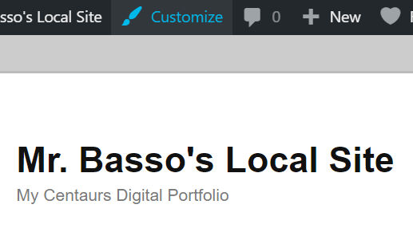
You will be able to locate the customize feature at the top of the website!
Step 3: Slide down to the bottom of your tool bar and click on “Homepage Settings”. This will bring you to your homepage displays settings where you will switch from a “static page” to “your latest posts”.
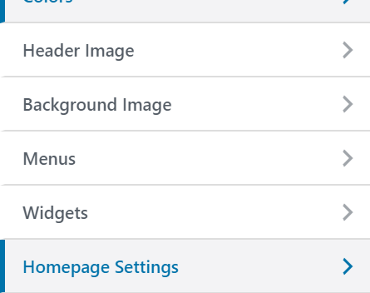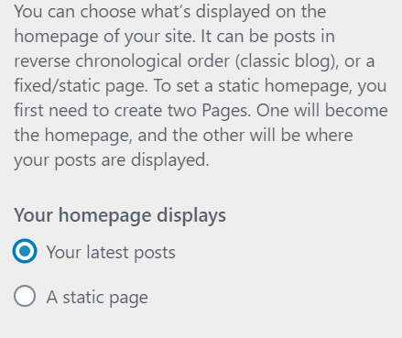
Step 4: Once you have changed your homepage display settings it is essential that your viewers can find your “About Me” page if they are looking to learn more about you. In order to do this you will need to go back to the customization bar and click “Menus” -> “About Me”
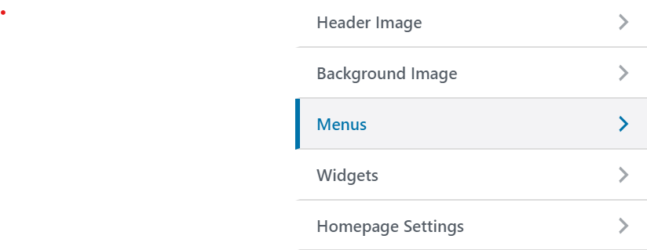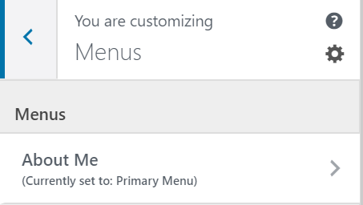

Step 5: Once you are in the “Menu” toolbar you will slide to the bottom and “Add items”. Once you reach this point please select your About Me page to add it to your primary menu.

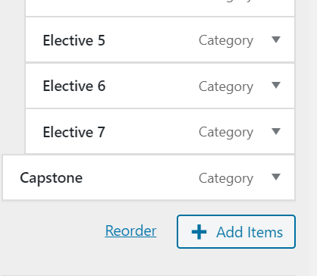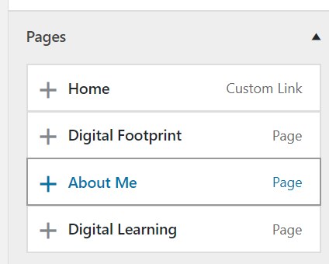

Step 6: Once you have added your “About Me” page to the Menu you must drag the page to the top of your menu to have it in order!
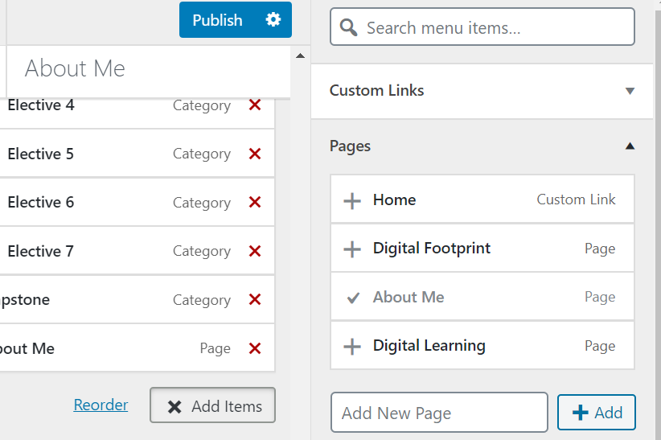

Step 7: Once you have moved your “About Me” page to the top of your menu bar you will be removing the “Digital Learning” and “Digital Literacy” Pages from your Menu Bar. You can do this by selecting (clicking) them in your menu customization. Once you select, there will be an option to remove the page from your menu… please do so!

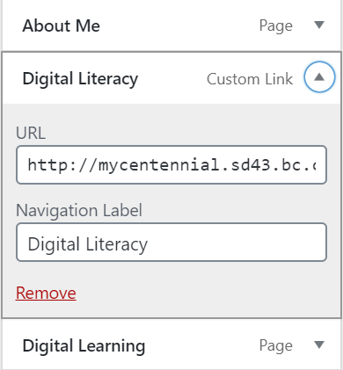
Once this step has been completed your Menu should look like this:

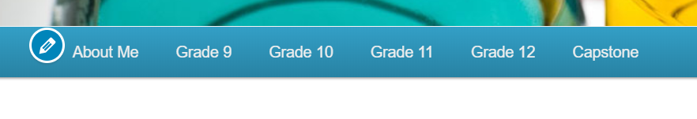
- After you have made the necessary changes to your blog you will notice one of the three following possibilities that could have occurred:
1. When you select the “About Me” page on your Menu you will find that your page is filled with information about you, including your favourite quote, picture, YouTube video, etc. If this is the case, you are all set!
2. You may find that when you select the “About Me” tab you will be brought to a page that is empty. This could have occurred for two reasons:
i. You did not complete your About Me assignment and this is the perfect time to start!
ii. You completed the About Me assignment as a series of posts. If this is the case all that you have to do is copy + paste your information from your post into your page!

Thank You for completing your workshop for the day! If you are in need of extra assistance with the changes to your blog please ask one of the wonderful ADL teachers or Tech leaders for help!

